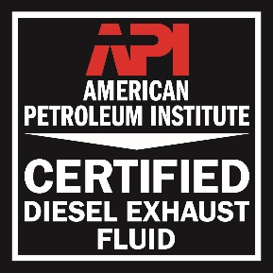
RUGGED DIESEL EXHAUST FLUID
ID# CRT-DEL-072611-00021
API LICENSE # 0102

CAPACITY | 55 GALLON
FILL DATE | 7/18/2018
DATE CODE | CP8-199

DEF

DEF

Hazard Statement:
None known

Precautionary Statement:
This material is not hazardous under the criteria of the Federal OSHA Hazard Communication Standard 29 CFR 1910.1200

First Aid Statement
First aid is not normally required. If breathing difficulties develop, move victim away from source of exposure and into fresh air in a position comfortable for breathing. Seek immediate medical attention.
If irritation or redness develops from exposure, flush eyes with clean water. If symptoms persist, seek medical attention.
Remove contaminated shoes and clothing and cleanse affected area(s) thoroughly by washing with mild soap and water or a waterless hand cleaner. If irritation or redness develops and persists, seek medical attention.
First aid is not normally required; however, if swallowed and symptoms develop, seek medical attention.

Health | 1
Flammability | 0
Reactivity | 0
Personal Protection

DOT SHIPPING NAME

 Denver, CO. 80216
(800)-580-4080

FOR HELP IN CHEMICAL
EMERGENCY
CALL CHEMTREC 800-424-9300
BEFORE USING READ & UNDERSTAND CURRENT SDS FOR THIS PRODUCT
ATTENTION:
This container can present explosion or fire hazards, even when emptied! To avoid risk of injury, do not pressurize, cut, puncture or weld on or near this container. Since emptied containers retain product residue, follow label warnings even after container is emptied.

